Performance Evaluation of MTN Mobile Network

Service Provider Operation in Akure Metropolis Using

Machine Learning.

Johnson Moyinoluwa a, Dahunsi Folashadeb, Kuboye Bamidele,c,[1]

Federal University of Technology, Akure Ondo, Nigeria

aDepartment of Innformation Technology

bDepartment of Computer Engineering

Abstract

The rapid growth in mobile subscriber numbers and the adoption of GSM technology has improved voice quality and data capacity, but the poor QoS remains a big concern globally, including Nigeria. However existing technical regulations were made available by the NCC as regards the boast and claims of MTN on the 4g network, many more existing evaluation approaches used in past research fall short of providing efficient, automated and accurate evaluation of MNOs operations and their Qos. This project aims to evaluate the performance of 4G networks in Akure metropolis, categorised into Urban, Suburban, and Rural. Tems Initiation software was used to collect data and machine learning was used to predict the quality of service (QoS). Call drops/Establishment, RSSI, Ec/o, and RSCP were KPIs used for prediction. t was inferred that network performance is highly unpredictable and

variable during the day (between 8am and 5pm) but greatly improves at the early hours of the

morning (between 12am to 6am) with a difference of about 69% between the peak and worst

performance. The study indicates that performance deteriorates at peak times (between 7pm and

11pm). Lastly the DNS performance analysis suggests that the MNOs’ DNS servers operate

effectively and do not add significant delay to end users’ queries

© 2017 Elsevier Inc. All rights reserved.

*Keywords:* Machine learning; Mobile networks; 4G Lte; Quality of service;

1. Introduction

The adoption of Global System for Mobile Communication (GSM) technology led to a rapid growth in mobile subscriber numbers. GSM is the most commonly used mobile standard globally due to its ability to enhance voice quality through digital modulation. The widespread adoption of the GSM standard has benefited both consumers and network operators. The introduction of GSM in Nigeria in August 2001 greatly impacted the field of information and communication technology (ICT). [1].

Mobile Wireless Communication networks have evolved dramatically during the previous few decades. The term "mobile wireless generation" refers to a shift in the system's nature, speed, technology, frequency, data capacity, latency, and other factors. Each generation has its own set of standards, capabilities, procedures, and characteristics that set it apart from the previous one.

The evolution of cellular technology also known as mobile wireless communication has advanced from the 1st generation (1G), 2nd generation (2G), 3rd generation (3G), fourth generation (4G) and the currently emerging 5th generation (5G). Each and every generation introduces new technology, frequency, data capacity, latency, higher data speeds including standards, capabilities, procedures and characteristics that differentiate them from the previous one.

The first generation (1G) wireless communication network was analog and only supported voice calls. The second generation (2G) introduced digital technology, enabling users to send and receive text messages. The third generation (3G) brought faster data transmission, increased capacity, and multimedia capabilities. The fourth generation (4G) builds on 3G by combining it with fixed internet to provide wireless mobile internet, which overcomes the limitations of 3G. It also improves bandwidth while reducing resource costs. The fifth generation (5G) worldwide has the potential to offer very high bandwidth, very low latency and high reliability human-centric communication, high user density, high-quality at high mobility, and enhanced multimedia services. 5G connection enables various automated systems to access more real-time data while using much less power, allowing IoT sensors with a lifetime of several years to be used. This kind of technology will expand robotics potential by enabling intelligent robots to function inside a larger smart environment. While there are fears that this may be utilized for military objectives or population tracking, the advantages to health technology cannot be underestimated[2].

Voice calls are currently not made on networks higher than 4G; Circuit switch fall back (CSFB) is used to convert from 4G to lower generations, such as 2G or 3G, so that calls may be made. If a phone is connected to Long Term Evolution (LTE) but does not support Voice over LTE (VoLTE), it must execute a CSFB in order to begin a voice call. CSFB is a method that transfers a user from 4G to 3G/2G (CS RAT) so that a CS Voice Call may be completed successfully. Incoming voice calls will fail if CSFB is not enabled on the network; however, outbound voice calls may still operate depending on the device. [3].

Machine learning has the potential to revolutionize the telecommunications industry in Nigeria. With the help of advanced algorithms and predictive analytics, network operators can identify and solve problems in real-time, optimize network performance and improve the overall user experience. Additionally, machine learning can help with network planning and optimization, reducing downtime and maintenance costs. The use of machine learning in the telecommunications industry will not only improve the efficiency of network operations, but also drive innovation and lead to the development of new, cutting-edge technologies. As Nigeria continues to grow its telecommunication infrastructure, the integration of machine learning will play a crucial role in ensuring its success.

1. Background

To clarify some relevant concepts and terminologies for the evaluation of MNOs performance based on machine learning. We outline general terms that are specific to this research field.

2.1 *Overview of the current research and trends in the field of MNOs provider performance evaluation.*

A GSM network is composed of several functional components. These functions and interfaces will be discussed in detail. The GSM network can be broadly classified into four main components: The Mobile Station (MS), The Base Station Subsystem (BSS), The Network Switching Subsystem (NSS), and The Operation Support Subsystem (OSS).

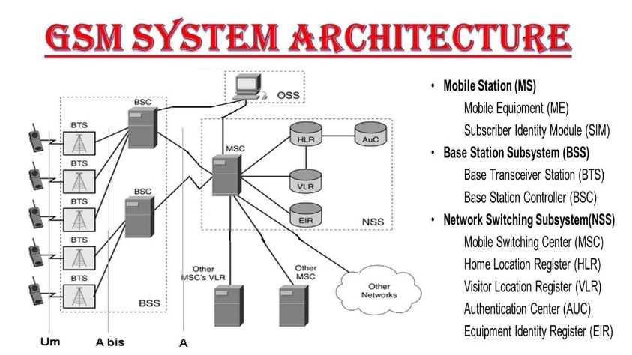

Fig. 2.1. GSM Architecture

*2.1.1* *Mobile station (MS)*

The Mobile Station (MS) is composed of physical equipment such as the radio transceiver, display, and digital signal processors, as well as the SIM card. It is responsible for providing the air interface for users in GSM networks. Additionally, the MS offers various services such as voice telecommunication services, data bearer services, and supplementary features services.

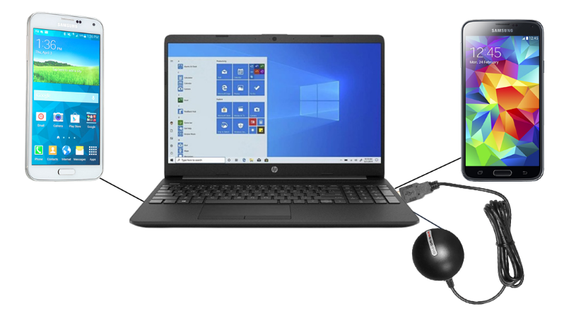

MS2

MS1

TEMS ENABLED LAPTOP

GPS

Fig. 2.2. TEMS Setup During Drive Test

*2.1.2* *Subscriber identity module*

The SIM (Subscriber Identity Module) is a microchip that is embedded on either a credit card-sized card (ID-1 SIM) or a small plastic piece (plug-in SIM). A GSM mobile phone cannot make any calls, except for emergency calls, without a SIM. The SIM enables personal mobility by allowing the user to access all subscribed services regardless of the location of the terminal or the specific terminal being used. A SIM card can be inserted into another GSM cellular phone to receive calls on that phone, make calls from that phone, or access other subscribed services.

*2.1.3* *The base station subsystem (BSS)*

The Base Station Subsystem (BSS) is a part of the GSM network that connects the mobile station (MS) to the network switching subsystem (NSS). It is responsible for providing the radio interface between the mobile station and the network. It includes the base transceiver station (BTS) and the base station controller (BSC). The BTS is the equipment that transmits and receives the radio signals to and from the mobile station, while the BSC manages and controls multiple BTSs and coordinates their activities. The BSS also manages the radio resources, including the frequency and time slots, and handles the handover process when the mobile station moves between cells.

*2.1.4* *The base transceiver station (BTS)*

is a key component of the Base Station Subsystem (BSS) in a GSM network. It is responsible for establishing and maintaining the radio link between the mobile station (MS) and the network. The BTS houses the radio transceivers that define a cell and handles the radio link protocols with the MS. In a large urban area, a large number of BTSs may be deployed. The BTS corresponds to the transceivers and antennas used in each cell of the network. It is usually placed at the center of a cell and its transmitting power defines the size of the cell. The BTS has between 1 and 16 transceivers, depending on the density of users in the cell.

It also includes functions such as encoding, encrypting, multiplexing, modulating, and feeding the RF signals to the antenna, transcoding and rate adaptation, time and frequency synchronizing, voice services, decoding, decrypting, and equalizing received signals, random access detection, timing advances, and uplink channel measurements.

The Base Station Controller (BSC) manages radio resources for one or more Base Transceiver Stations (BTSs). It manages radio channel setup, frequency hopping, and handovers. The BSC connects the mobile and the Mobile Switching Center (MSC), and converts the 13 Kbps voice channel from the radio link to the standard 64 Kbps channel used by PSTN/ISDN. The BSC allocates and releases frequencies/time slots, handles inter-cell handovers, and controls power transmission. It also performs functions such as frequency hopping control, traffic concentration, interface with the Operations and Maintenance Center for the BSS, frequency reallocation, synchronization, power management, and time-delay measurements of MS signals.

*2.2* *The network switching subsystem (NSS)*

is a component of a mobile telecommunications system that handles call switching and mobility management. It is responsible for routing calls between mobile users and the public telephone network. The NSS also manages the mobility of users by updating their location information and maintaining connections as they move from one cell to another. The NSS typically includes components such as the Mobile Switching Center (MSC), Visitor Location Register (VLR), and Home Location Register (HLR). The NSS plays a crucial role in enabling mobile communication services and ensuring their reliability and seamless operation.

system that handles call switching and mobility management. It is responsible for routing calls between mobile users and the public telephone network. The NSS also manages the mobility of users by updating their location information and maintaining connections as they move from one cell to another. The NSS typically includes components such as the Mobile Switching Center (MSC), Visitor Location Register (VLR), and Home Location Register (HLR). The NSS plays a crucial role in enabling mobile communication services and ensuring their reliability and seamless operation.

*2.2.1 The home location register (HLR)*

is a database that manages and stores subscriptions. It is the most crucial database as it holds permanent data on subscribers, including their service profile, location, and activity status. When a person buys a SIM card, the subscription information is recorded in the HLR of the operator.

*2.2.2 The mobile services switching center (MSC)*

is the central component of the Network Switching Subsystem. It switches calls between mobile and other networks and manages mobile services like registration, authentication, location updating, handovers, and roaming call routing. The MSC also performs functions like toll ticketing, network interfacing, and common channel signaling. Each MSC has a unique ID.

*2.2.3 The visitor location register (VLR)*

is a database with temporary information on subscribers required by the Mobile Services Switching Center (MSC) to service roaming subscribers. The VLR is integrated with the MSC. When a mobile device enters a new MSC area, the VLR connected to that MSC requests data from the Home Location Register (HLR). This enables the VLR to have the information needed for call setup without repeatedly accessing the HLR.

*2.2.4 The authentication center* (AUC)

is a secure database that holds a copy of the secret key stored on each subscriber's SIM card. It is used for authentication and encryption of the radio channel and protects network operators from fraud.

*2.2.5 The equipment identity register (EIR)*

is a database with a list of all valid mobile devices on the network. Each device is identified by its International Mobile EquipmentIdentity (IMEI). An IMEI is marked as invalid if it is reported stolen or fails to meet approval standards.

2.2.6 *The operation support subsystem (OSS)*

is a component of the telecommunication infrastructure that provides support for the operations, administration, maintenance, and provisioning of the network. It helps in monitoring, troubleshooting, and configuring network elements, ensuring the smooth functioning of the network. The OSS also facilitates billing and customer service functions and provides an interface for network management. The goal of OSS is to increase network efficiency and availability while reducing operational costs.

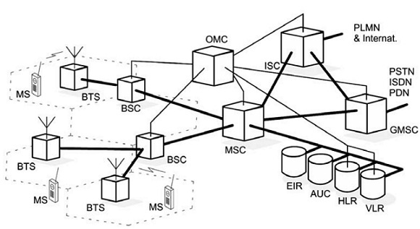

Fig. 2.3: How the OMC system covers all the GSM elements

*2.3**Qos evaluation metrics*

Quality of Service (QoS) refers to the performance of a service as directly measured by network analysis. It is objective, based on reality and quantifiable, rather than subjective opinions (people opinion), and is measured using available systems.

*2.3.1 Call setup success rate (CSSR)*

is a performance metric that measures the success rate of establishing a call between two parties exchange of signaling information in the call process that leads to Standalone Dedicated Control Channel (SDCCH) seizure. It is calculated as the number of successful call setups divided by the total number of call setup attempts. CSSR is an important indicator of network performance and is used to evaluate the quality of service offered by a network operator. A high CSSR value indicates that the network is able to provide reliable and efficient call connections, while a low CSSR value may indicate network congestion or other issues that need to be addressed.

**Mathematically, = (1 – Blocking Probability)**  2.1

*2.3.2 Call drop rate (cdr)/dropped call rate (DCR)*

is a performance metric that measures the frequency of dropped calls. It is calculated as the number of dropped calls divided by the total number of call attempts. A dropped call is a call that ends prematurely before either the caller or the receiver can end it properly. The CDR/DCR is an important indicator of network performance, as a high rate of dropped calls can indicate network congestion or other issues that need to be addressed.

**= 1- Call Completion Probability 2.2**

*2.3.3 Call completion rate (CCR)*

The Call Completion Rate (CCR) is the ratio of successfully completed calls to the total number of attempted calls. A completed call is one that ends normally, either during the ringing phase or conversation phase, by either the caller or the recipient.

**= 1- Call drop Probability 2.3**

*2.3.4 Call handover success rate (CHSR)*

Call Handover Success Rate (CHSR) is a metric that measures the success rate of a call handover process, which refers to the seamless transfer of a call from one cell to another during a mobile call. Its formula is calculated by dividing the number of successful handovers by the total number of attempted handovers.

**2.4**

*2.3.5 Traffic channel congestion rate (TCCH)*

Traffic Channel Congestion Rate (TCCH) is a measure of network congestion on a particular traffic channel, which indicates how many calls are unable to be connected or are being blocked due to a lack of available resources on the channel. It is calculated as the number of blocked calls or failed call attempts divided by the total number of call attempts on a specific traffic channel. TCCH helps in evaluating the performance of a network and determining the need for network expansion or optimization.

**2.5**

* + 1. *Standalone dedicated control channel sdcch*

SDCCH (Standalone Dedicated Control Channel) is a type of control channel in a GSM (Global System for Mobile Communications) network that is dedicated for use in sending signaling messages for call setup and control. It provides a separate channel for these messages, allowing the voice and data traffic channels to be used solely for their intended purpose. SDCCH is critical for maintaining the integrity of the network and ensuring efficient call setup and control.

**2.6**

2.4 Drive tests

Drive Tests are widely used by mobile network operators to evaluate network quality and troubleshoot issues. They assess coverage, capacity, and QoS by measuring RF parameters of the network using a mobile measurement tool in a vehicle. Drive Tests collect data in the form of log files, which are then analyzed to determine the coverage, capacity and Quality of Service of the network in a specific geographical area. The technique consists of using a motor vehicle containing mobile radio network air interface measurement equipment that can detect and record a wide variety of the physical and virtual parameters of mobile cellular service in a given geographical area. ([4]

*2.4.1 Drive test hardware tools*

*2.4.2 Laptop*

The laptop serves as the main hub for the operating system and data collection software (TEMS Investigation). It must have a minimum of 120GB HDD and 4GB RAM to effectively manage all equipment in the system.

*2.4.3 Inverter*

The inverter is a power source for the whole setup, converting 12v DC from a vehicle's cigarette port to 220v AC needed by the data collection device. A 500w, 12v to 220v, 50Hz inverter was used for the drive test

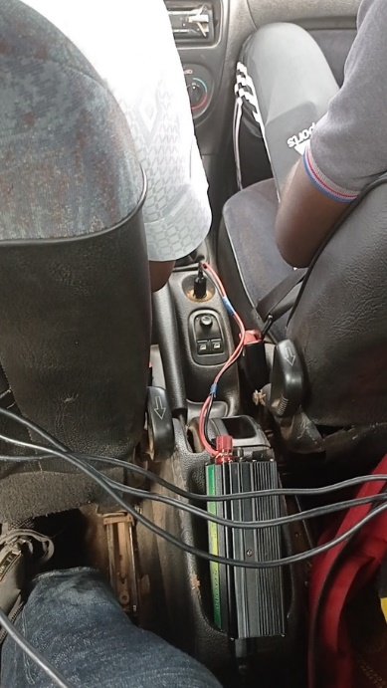

Fig. 2.4: Car Inverter

*2.4.5 Global positioning system (GPS)*

The GPS system (G-STAR BU-353S4) is a part of the global navigation satellite systems (GNSS) that provides location and time data to a GPS receiver anywhere on Earth with an unobstructed view of at least 4 GPS satellites. It's used in drive testing to track the location of the testing vehicle and identify areas where network optimization is needed.

*2.4.6 Usb hub and cables*

During testing that requires multiple external devices, such as clustering or benchmarking, the laptop's limited number of USB ports may not be enough to connect all the equipment. In such cases, a USB port extension can be used to provide additional ports for connecting all the mobile stations.

*2.4.7 Mobile station (phone)*

The Mobile Station used in drive tests is a phone with a sim card, connecting to a PC. it is used to initiate calls during data collection. Multiple mobile stations can be used depending on the mode and service provider being tested. Sony Ericsson's W995 is the preferred phone for full utilization of TEMS software, while Samsung S5 is compatible but has limitations. The mobile station acts as a modem and receiver for the TEMS software during the drive test.

*2.5 Drive test software tools*

*2.5.1 Tems discovery (Test Mobile System)*

TEMS Discovery is a top-notch platform for mobile network performance testing, offering exceptional insight into network performance as experienced by subscribers on devices, applications, and network level. [5] notes that it is the most comprehensive network analytics and optimization platform in the wireless industry. TEMS Discovery has the capability to review drive test log files and produce reports.

TEMS Discovery provides the ability to analyze drive test log files and generate reports.

1. Designed but can also be used for Benchmarking and QoS verification
2. Flexible tool that is easy to adapt to the working process
3. Automated data processing
4. User defined KPIs
5. Inbuilt reporting
6. Excellent post processing solution for TEMS Investigation and TEMS Pocket

TEMS Discovery can support the following technology. So, the network quality of these items can be analyzed by using TEMS Discovery.

1. IS -95/CDMA20000 1x
2. EV-DO (Rev.0/ Rev. A)
3. GSM/GPRS/EDGE
4. WCDMA/HSDPA/HSUPA/HSPA+
5. TD-SCDMA
6. WiMAX
7. LTE

TEMS Discovery analyzes pre-existing log files from TEMS Investigation software and generates reports. It cannot record log files during the drive test. It reads recorded events from the Investigation software and displays the frequency and magnitude of KPIs over time. The drive test utilized TEMS Discovery 10.0."

*2.5.2 Tems investigation*

TEMS Investigation is a widely used tool for data collection in over 180 countries. It is the industry standard for maintaining and optimizing wireless networks, supporting all major technologies. With features for data collection, real-time analysis, and post-processing, TEMS Investigation is a cost-effective, compact solution for field engineers. It has been the leading innovator in drive testing for two decades and eliminates the need for multiple tools. It is ideal for both new network rollouts and seamless integration with existing networks, and is effective in measuring and monitoring digital networks[6] [7]

1. GSM
2. WCDMA
3. HSPA
4. LTE
5. CDMA

For over two decades, TEMS has been leading the way in drive testing features and functions. As a single equipment with multiple functions like data collection, real-time analysis, and post-processing, TEMS Investigation reduces costs and saves time and effort for operations staff.

To ensure compatibility with new technologies, it is recommended to use the latest version of TEMS Investigation. The collected data is stored on the laptop and provides valuable information for network optimization, verification, and maintenance. TEMS Discovery can be used to easily view the results. Although TEMS Investigation 16.3.1 can be used for minimal analysis.

Once the tools for the drive test (mobile station, GPS, dongle, etc.) are connected to the laptop with TEMS Investigation software installed, synchronization with the devices occurs after a few seconds and a sound indicates successful synchronization. These tools enable the software to read the network signals, which allows the software to track and monitor KPIs during the drive test.

1. Literature Review

[8] carried out Evaluated the performance of 4 mobile networks - Operator A, B, C, and D - that provide voice communication services at the University of Ilorin, Nigeria. Data was collected through drive tests of GSM and WCDMA radio frequencies at the main campus and staff quarters. Results were obtained using TEMS Discovery device and Microsoft Excel 2013 to compare accessibility, retainability, mobility, and service integrity with NCC's target KPI. The results showed that the WCDMA network performed poorly compared to the NCC's KPI target and was below customer satisfaction, while the GSM network was acceptable. Recommendation: network operators should monitor, optimize, and improve services and invest in resources to meet customer satisfaction and increase revenue. Graphs, diagrams, and charts were used to showcase the deviation from NCC targets, and the results revealed which operator had the best performance in these locations. The focus of this paper was on the evaluation and resolution of network issues only.

[9] discussed penalties for failing to meet the quality-of-service benchmark for consumers. The Nigerian Communications Commission imposed 1.7 million Naira on MTN, Etisalat, Airtel, and Globacom. A drive test was conducted in 2012 and the major network providers (MNOs) failed to meet standards. The researchers conducted their own research in 2016 and found little improvement. The KPIs were used to compare the networks, with Globacom ranking best for CSSR, Etisalat for signal-to-noise ratio, and Airtel for HOSR. This suggests that some KPIs may not be interrelated, as favourable circumstances for one KPI may lead to failure in another.

[10] found a linear relationship between call setup success rate and other key performance indicators (KPIs) while investigating Globacom network in three parts of Akure, Nigeria. The KPIs such as CSSR, HOSR, TCH, SDCCH-SR, CDR, and CSR were used to evaluate the network's quality of service. The average values were below NCC's standard of 99.8%, but SDCCH was found to be maximized within the three local government areas. The KPIs showed varying degrees of correlation and must be improved for Globacom to perform better. The NCC requires CSSR to be ≥98% and CSR to be ≥97%, but both were found to be lower in Ifedore, Akure North, and Akure South local government areas. Traffic channel availability should also be increased to improve network performance.

[11] conducted a similar analysis to [8] for a different metropolis, Oshogbo. They found that the service provider did not meet NCC's standards, as shown by the analysis of received signal strength in dB [12]. [13] provided a legend for received signal strength and the NCC standards for call quality of service, as did [11]. Which is also shown below.

Table 2.2: Coverage Signal Strenght [13]

|  |  |
| --- | --- |
| **Coverage Signal Strenght** | |
| Coverage | ≤5 secs |
| Good | ≤2% |
| Fair | ≤98% |
| Bad | ≤2% |
| Non Existent | ≤96% |

Table 2.3: KPIs and their threshold levels [14], [15],[16]

|  |  |
| --- | --- |
| **Some KPIs and their threshold level in %** | |
| Call setup time | ≤5 secs |
| Call failed rate | ≤2% |
| Call setup succes rate | ≤98% |
| Call drop rate | ≤2% |
| Call setup rate | ≤96% |
| Call Handover success rate | ≤98% |
| Standalone Dedicated Control Channel | ≤0.2 |
| Speech Quality Index | ≥-3.8 |

[17] assessed the performance of two major GSM networks in Ilorin Metropolis, Nigeria using three KPIs: CSSR, RSL and CDR. The networks, referred to as Network "A" and Network "B", did not meet the NCC's ≥ 98% CSSR and ≤ 2% CDR standards. The data was collected for 2 weeks in May 2018, from 20 subscribers in different parts of Ilorin. About 2000 calls were monitored using Rant Cell Pro, and signal strength values were obtained using SignalDetect on Android, at 10-second intervals. The study found that GSM operation faced numerous challenges ranging from network providers, regulatory agencies to the Nigerian government.

[18] A hybrid model for managing signal traffic congestion in Nigeria's GSM network was developed. The model's performance was evaluated using key parameters, including CSSR, CDR, CCSR, and TCHCR. The paper explores different schemes such as block time sharing, dynamic allocation with/without time slicing, recent call allocation, and priority allocation to improve QoS in GSM networks. The model takes into account call prioritization and buffering of handover calls as means to prevent congestion. Drive tests and KPIs were used to evaluate the network's performance in real-life scenarios, with drive tests being more significant as they reflect customer experiences. The drive tests involved data collection and analysis using TEMs, GPS receiver, and Microsoft Word. The results of the drive tests in Port Harcourt from January to April 2014 were analyzed using Excel. The characteristics of the two systems are presented in the results and discussion section of the paper.

[19] in this research work an app called MBPerf was created using Java and XML to measure 4 QoS metrics (download/upload speed, latency, and DNS lookup) on volunteers' Android phones. The data was collected for 3 months in Akure and Ibadan from the 4 major MNOs in Nigeria. Results showed that 3G users received speeds 10% below the 500 kbps benchmark, while 2G users received speeds 61% above the 100 kbps benchmark. The study found that network performance is variable during the day and improves in the early morning, but deteriorates during peak hours in the evening. The DNS performance analysis showed that MNOs' DNS servers operate effectively.

To address this, a host and crowdsourced measurement approach was developed. The system architecture has 3 parts: client front-end, communication links, and server backend. The client front-end consists of an Android phone and the MBPerf app. The data was collected between Jan-Mar 2018 using the MBPerf app installed on volunteers' phones. The volunteers were recruited through WhatsApp and one-on-one campaigns, including students and staff of FUTA, friends, and family. The MBPerf .apk file was downloaded from the website or sent as an email attachment.

[20] the goal of this study is to design a hybrid model to evaluate the quality of service (QoS) for voice calls offered by Mobile Network Operators (MNOs) based on standard performance metrics. This is accomplished through an experimental study using data collected from volunteers' mobile phones through a host-based crowdsourced technique. The collected QoS data is modeled using a combination of Fuzzy Logic and Takagi Sugeno Kang algorithms in a Neuro-Fuzzy model, implemented in MATLAB and Weka with MySQL as the backend on Windows 10. The hybrid model showed high accuracy (97.10%) with 95.5% true positive rate and 97.47% precision.

The voice QoS app was installed on volunteers' smartphones to measure voice call duration, KPIs, location parameters, network data, and other user information. The app captured CSSR, CDR, TCHR, and RSS, and location parameters were recorded using GPS or GPRS. The system also collected other device information such as device ID, model, and SIM serial number.

A total of 482,520 voice call data were collected over 12 months, with an average of 93 calls per volunteer. The data was preprocessed and reduced to 5157 records for analysis. The preprocessing involved data discretization and feature selection.

[21] This paper proposes a QoE modeling method using Artificial Neural Networks (ANN) based on QoS parameters. We evaluated and synthesized QoE in a real-world environment with the help of Drive Tests. We analyzed the relationship between QoS parameters and Opinion Score (OS) before selecting parameters for the QoE model and synthesizing them. QoS and OS datasets were collected from end devices and subjective evaluations by a group of defined users for multimedia services (YouTube, Facebook, Line, and Web browser). ANN properties allow us to efficiently learn human behavior from the collected datasets, generating a QoE model and estimating QoE scores without relying on real humans. The results from parameter synthesis were used to guide network improvement towards a QoS-based user-centric approach.

The main objective for developing this application is offers a system that can measure the performance of a mobile data communications network with to develop a measurement tool End-to-End QoS (client software) that is suitable for the mobile environment through traffic users, and to summarize the results of its performance test, determine the extent to which performance of QoS on ISP using each service pack featured mobile operator.

[22] His work presents a database with subjective assessment scores and QoS parameters of 70 H.264-encoded video test sequences that were corrupted during transmission over a 3G LTE network simulator. A new NN-based assessment method is proposed, trained to determine weights. The pseudo-subjective scores are compared to the true MOS results in the database. The accuracy of the NN prediction tool needs to be tested outside of the training set, with persistent residual errors. The errors can be reduced through post-processing with particle swarm optimization for improved accuracy. The method has potential for Quality-of-Experience-aware network optimization for LTE network operators.

[23]This paper proposes a solution using a transformer pre-trained language model to mine user concerns and sentiment polarity from comments, encoding preferences with CNN and QoS with multi-layer Bi-LSTM using an attention mechanism. The model shows high accuracy in sentiment polarity prediction and expresses differentiated preferences of users in a composite service scenario. The relationship between QoS and QoE has been a topic of interest for years, but constructing an accurate QoS/QoE correlation model for complex composite services from multiple domains is challenging. The imbalance of QoS and QoE parameters and personalized preferences of different users are factors that make traditional end-to-end models inaccurate.

[24] his work evaluated the type, purpose, and speed of broadband network performance in Nigeria, with rural areas represented by Ilesa and Oba-Ile in Akure, and urban areas by Abuja and Lagos. Random questionnaires were given to users in these areas and the data analyzed. The majority of respondents used wireless broadband with download speeds above 100 mbps in urban areas and lower in rural areas, with MTN having the most subscribers. The study found that 3G systems were deployed as broadband instead of 4G. The study also reviewed the evolution of wireless networks and related works on broadband. Data was collected through a survey of 120 respondents from the four locations chosen, who represented different professions and personal assessments of QoS were analyzed. SPSS was used as the statistical tool.

[25] This paper reports initial findings from a study of mobile broadband network speed in Nigeria. Uyo and Eket were selected for testing and measurements were conducted using a mobile app from the user's perspective. Results show a significant gap between actual and expected broadband speeds. A proposed framework for a more comprehensive measurement system using a Raspberry Pi test bed is in development. This system will have remote access and communication features and will be deployed across Nigeria, enabling data collection and thorough analysis of mobile broadband performance."

[26] This article used , the OMNeT++ simulator was used to assess the performance of LTE networks by varying the number of user equipment (UE) connected to evolved Node Base stations (eNB), UE distance from eNB, and UE mobility speed. Performance metrics used were throughput, end-to-end delay, and packet loss. The results showed that the LTE network is capable of delivering good voice call quality but its performance is impacted by the increasing distance between UE and eNodeB, the number of connected users, and user mobility speed.

[27] employed ANNs to predict call drops in communications systems using five GSM QoS parameters (RxLev, RxQual, FER, BER, and Timing Advance). But, the study didn't consider the crucial parameter SNR, which affects call quality. A higher static noise level raises interference, making calls harder to hear and resulting in dropped calls [28]. [29] used SNR and other parameters (received signal strength and link quality indicator) in their wireless link quality model. Adding this important parameter to the model will enhance its accuracy and precision. (Mebawondu, 2021) used six machine learning algorithms to evaluate audio QoS of operators via crowdsourced data. Based on evaluations, ID3 performed best in accuracy followed by SVM, C4.5, Neural Network, Fuzzy, and ANFIS (in that order). ID3, SVM, ANFIS, and C4.5 ranked first, second, third, and fourth in precision, respectively. [27] used FFNN in ANN and achieved 87.5% accuracy. It's worth noting that [20] didn't include ANN in his analysis and ID3, a Decision Tree algorithm, performed better in accuracy and precision. Data anomalies can reduce accuracy and precision in machine learning, so it would be beneficial to compare ANN and Decision Tree algorithms.

Network operators aim to either generate revenue by sharing data with external parties or to optimize internal operations. Key to achieving this is using machine learning to analyze large amounts of network data and extract valuable insights while preserving communication resources. Machine learning can be applied to solve telecom problems, such as predicting wireless link status to prevent TCP congestion during disconnections. A study [30] reviewed the use of machine learning in telecom and found that the Naive Bayes classifier can be applied in a supervised learning manner.

1. Methodology

The architecture of the proposed traffic congestion prediction model using machine learning techniques is presented in Figure 3.1. The architecture was divided into several phases namely; the data preparation phase, data splitting phase, modelling phase, classification phase, model evaluation and tuning phase, and lastly, the result phase.

The data preparation phase consists of two additional sub-phases namely; data processing and wrangling, and feature extraction. The data preparation phase is the phase where data gathered from an online survey were cleaned, wrangled, curated, and prepared before any machine learning techniques are applied and before the model building is carried out. In the data splitting phase, the well-prepared data coming from the data preparation phase were split into the training set, which contains 70% of the well-prepared data, and the testing set, which contains the remaining 30% of the well-prepared data. In the modelling phase, machine learning algorithms such as Logistic Regression, Linear Regression, Support Vector Machine, and Decision Tree were employed on the training set.

In the classification phase, the trained model was used to predict the unseen data, which in this case is the testing set.

In the model evaluation and tuning phase, the performances of all the machine learning algorithms were evaluated based on metrics like accuracy, f1-score, precision and others, whereby poor-performing algorithms were further tuned in a process called hyperparameter optimization. In the result phase, the algorithms’ accuracies were compared and the best-performing algorithm was used to make the final prediction. The performance evaluation prediction model using machine learning techniques is outlined in Figure 3.1 and divided into six phases: data preparation, data splitting, machine learning model (modelling), classification (Trained model), evaluation, tuning, and results. The data preparation phase includes data processing and wrangling, as well as feature extraction. The phase involves cleaning, organizing, and preparing data from an online survey for use in machine learning. The data splitting phase divides the prepared data into 70% for training and 30% for testing. During the modelling phase, machine learning algorithms such as Logistic Regression, Support Vector Machine, and Decision Tree are applied to the training set. The classification phase uses the trained model to predict the testing set. The evaluation and tuning phase evaluate the performance of each algorithm based on accuracy, f1-score, and other metrics, and adjusts poor-performing algorithms through hyperparameter optimization. Finally, the results phase compares the accuracy of the algorithms and selects the best-performing one for the final prediction.

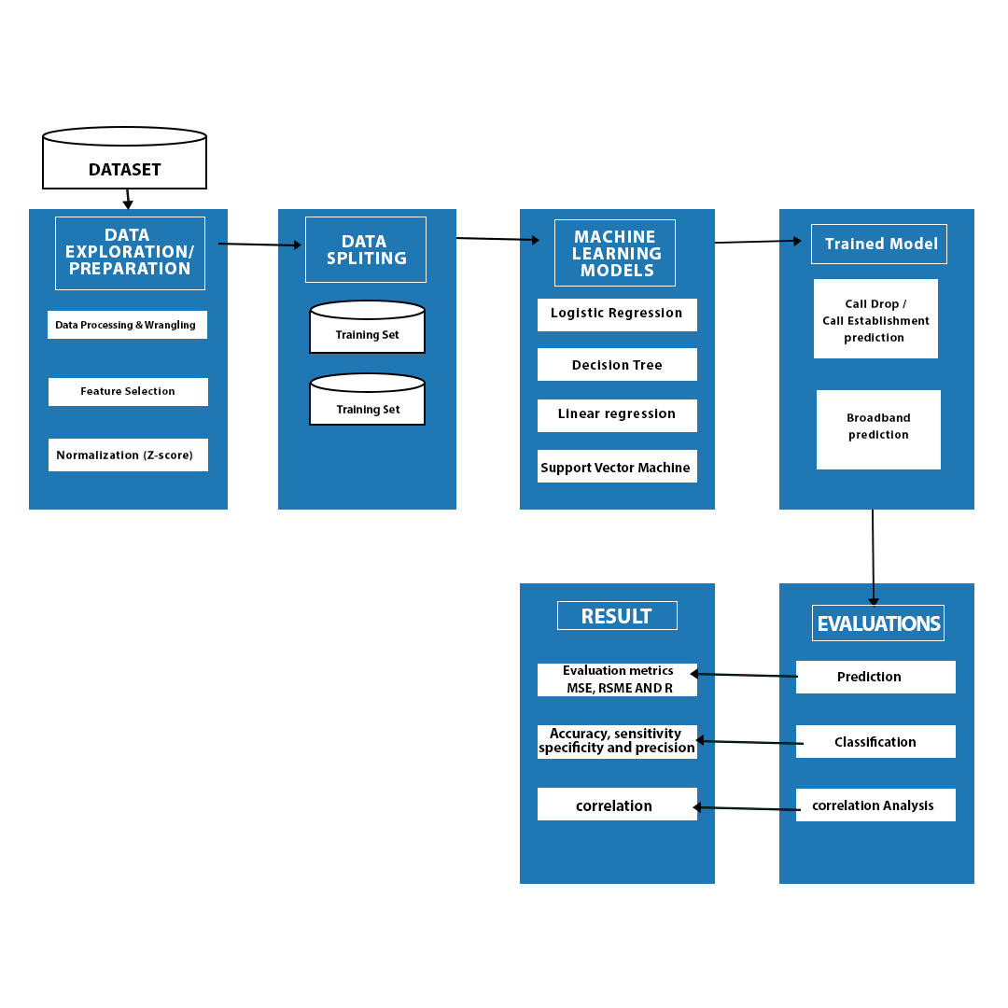

Fig 3.1: Architecture design of the Call drop and Broadband QoS Prediction Model

COLLECTION OF DATA

PROCCESSING OF DATA

TRAINING

PREDICTING

KNOWLEDGE DISCOVERY

RESULT

COMPARATIVE ANALYSIS OF ML ALGORITHMS

**Fig. 3.2: Flowchart of the Call drops and Broadband QoS Prediction Model**

**3.1 Scope**

This study collects QoS metrics data for voice and broadband from selected mobile network operators. ML techniques will be applied to pre-process the data, including cleaning and outlier detection. Exploratory data analysis will be performed to uncover insights, followed by the development of a model to detect call drops in communication systems.

**3.2** **GEOGRAPHIC DESCRIPTION OF THE COVERAGE AREA**

Akure is the largest, busiest city and capital of Ondo State, located in the southwestern Nigeria region of Nigeria, known for its commerce, education, agriculture and political activities. Akure, the state capital, is rapidly developing into a commercial and industrial centre and is the site of a federal university of technology. With a population of 484,798 as of the 2006 census, it is located at Latitude 7° 15' N, Longitude 5° 11' E, and has an elevation of 350m, making it a highland within the western uplands. It is the largest city in Ondo state, covering an area of 991 km2 Oluwadare & Julius,( 2015). The study's focus is on the Federal University of Technology (FUTA), its surroundings, and towns from Ibule Junction to Oba Ile, with varying daily starting and ending routes during the drive test.

Due to the high concentration of people, businesses, and institutions, the FUTA campus and its surrounding areas (Southgate, Northgate, and Roadblock) were classified as a "Urban settlement" for the purposes of this project. In addition, the areas around Obaile town and the airport axis were classified as a suburban settlement, while the areas around Oba Adesida axis, next to arakale, heading in the direction of nepa and illesha garage, were classified as an Akure rural settlement.

**Fig 3.3: Map of Nigeria showing Ondo state** [31]

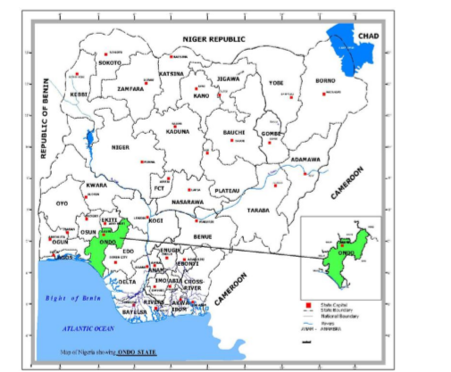

**3.3** **DATA COLLECTION**

The standard drive test method will be employed in data collection to assess network and service quality in the measurements. A mobile vehicle equipped with measurement equipment will conduct drive tests to measure QoS indicators for a cellular network in a specific area. Each network operator will have a measurement device and separate SIM cards for different networks, known as benchmarking. The host-based approach will be used to gather data for broadband QoS.

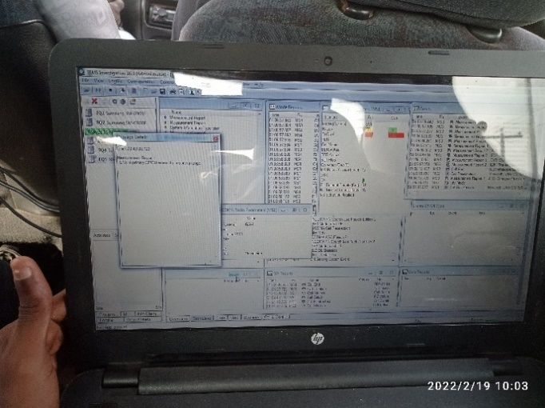

**Figure 3.4: Data collection during Drive test**

3.4 SAMPLE SIZE AND DATA PROCESSING

Data collection spanned 4-8 weeks, categorized as hourly, weekly, and monthly. Exploratory data analysis was done to show what was obtained during the different periods, considering location and demographics. Outlier detection in data pre-processing will be done using the k-means clustering algorithm.

3.5 SITE SELECTION

In addition to collecting KPIs via calls, the signal strength (RSSI, RSRP, RSRQ) can be used for site selection. Handover failures can also be analysed to identify areas with low signal strength and high handover failure rates, and suggest suitable sites for placement.

3.6 DATA SPLITTING

In machine learning, data splitting is a commonly employed technique that involves dividing data into three distinct sets: training, testing, and validation. The objective of this approach is to obtain an unbiased assessment of the algorithm's performance on real-world data. The process begins by using the training set to build a machine learning model, which is then fine-tuned through hyperparameter optimization using the validation set. Once the optimal hyperparameters are determined, the performance of the model is evaluated on the test set. In this study, the data was divided into a training set and a test set, with a ratio of 70% and 30% respectively.

3.7 TRAINING SET

For the construction of the hybrid model, the complete Call drops and broadband dataset was divided into a training set and a test set. The training set consisted of 70% of the data and comprised 199 rows with 8 attributes for the call drop prediction model and 364 rows with 17 attributes for the broadband prediction model. The models were developed by observing and learning from this data and optimizing their parameters to accurately predict call drops and broadband performance.

3.8 TESTING SET

The testing set is an essential component of the model evaluation process. It is used to objectively evaluate the performance of the final model on unseen data and provide an estimate of its ability to generalize to new situations. Once the model has completed training with the training set, the testing set is applied to simulate real-world conditions. In this study, 30% of the Call drops and broadband dataset was designated as the testing set. Specifically, 51 rows of the call drop data were used to evaluate the call drop prediction model, while 156 rows of the broadband data were used to assess the performance of the broadband prediction model.

3.9 MODEL TRAINING AND CLASSIFICATION

Once the data is prepared, features are extracted, and the result from pre-processing is split into training and testing sets, then the models need to be built. The models used for the training and testing process for call drop are Logistic Regression and Decision Tree classifier while Linear regression and Support Vector where used for the broadband data .

3.9.1 MODEL PERFORMANCE ASSESSMENT CRITERIA

Once the classification is complete, it is crucial to validate the model's performance on the testing set of the dataset. To assess the performance of the call drop prediction model, several evaluation metrics were used, including Accuracy Score, Classification Report, Confusion Matrix, Precision, F1-Score, Recall, and ROC-AUC Curve. These metrics provide a comprehensive evaluation of the classifier's performance and provide insights into its strengths and weaknesses. For the broadband prediction model, a set of metrics such as RMSE, MSE, R2 Score, Throughput Mean, and others were used. While each of these metrics has its advantages and disadvantages, it is recommended to use a combination of metrics instead of relying on a single measure for a more robust evaluation of the model's performance.

3.9.2 CONFUSION MATRIX

The confusion matrix is a valuable tool for evaluating the performance of classification models on the test dataset. It provides a summary of the model's predictions, indicating which instances were correctly and incorrectly classified. The confusion matrix is represented as a square table, with the count values of true positive (TP), false positive (FP), true negative (TN), and false negative (FN) predictions. The counts of correct and incorrect classifications are presented in the table, with all correct classifications appearing along the principal diagonal (TP and TN) and incorrect classifications located off the diagonal (FP and FN). The confusion matrix, as shown in Table 3.1, provides a clear and concise overview of the model's performance, making it a useful tool in model evaluation.

Table 3.1: Confusion Matrix for two classes

|  |  |  |  |
| --- | --- | --- | --- |
| **Predicted Class** | | | |
|  |  | Negative (0) | Positive (1) |
| **Actual Class** | Negative (0) | TN | FP |
| Positive (1) | FN | TP |

TP is an outcome where the model predicts the positive class accurately. FP is the situation that model predicts the positive class inaccurately. TN is an outcome in which the model accurately predicts the negative class. FN is an outcome in which the model predicts the negative class inaccurately [32]

**3.9.3 ACCURACY**

Accuracy is a key metric for evaluating the performance of a classification model. It measures the proportion of correctly classified instances, both positive and negative, in a particular dataset. The accuracy is the ratio of true positive (TP) and true negative (TN) predictions and is an important indicator of a model's success. An ideal classifier should have a high degree of accuracy, as expressed mathematically in equation 3.1 [32]. The accuracy metric provides a clear and concise summary of the model's performance and is widely used in machine learning and data science.

**3.9.4 PRECISION**

Precision is calculated as the ratio of correct positive outcomes to the total number of positive predictions made by a classifier. It reflects the accuracy of positive identifications, and the higher the precision, the better the classifier. Precision can be mathematically represented as shown in equation 3.2 [32][33]

**3.9.5 RECALL**

Recall or Sensitivity is used to calculate the proportion of actual positives that are correctly classified. An ideal classifier should have a higher degree of recall. It is mathematically expressed in equation 3.3 [32] [33]

For the Performance Evaluation of broadband models were evaluated using two well-known metrics: the R2 score and the root mean square error (RMSE). In the following subsections, the two metrics are described.

**3.9.6 R2 SCORE**

Also called the coefficient of determination, the R2 score is a goodness-of-fit measure for regression models. It indicates the percentage of the variance in the dependent variable that can be explained by the independent variables. The R2 score measures the strength of the relationship between the model and the dependent variable on a convenient 0 – 1 scale. The R2 score is computed by:

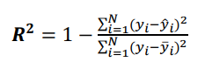 3.4

**3.9.7 RSME**

Root Mean Square Error (RMSE) The RMSE is the standard deviation of the prediction errors, also called the residuals. The residuals show the difference between the actual data values and values predicted by the model. The RMSE is used to measure how the residuals are dispersed. Moreover, it can be used to compare the prediction errors of different models to determine the model with the highest performance on the data. The RMSE can be calculated by the following equation:

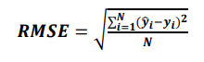 3.5

**3.9.8 MSE**

Mean squared error (MSE) is defined as the mean or average of the squared differences between the actual and estimated values. Mean Squared Error (MSE) measures the amount of error in a statistical model. Evaluate the mean squared difference between observed and predicted values. If the model has no errors, the MSE is zero.

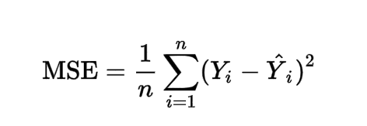 3.6

1. RESULT AND DISCUSSION

**MODEL CLASSIFICATION**

The call drop and call establishments dataset was trained and tested using two machine learning algorithms namely, Logistic Regression and Decision Tree. While the broadband dataset was also trained and tested using two machine learning algorithms namely, Linear regression and Random Forest Regressor.

#### LOGISTIC REGRESSION

Using the scikit-learn library, which is a machine learning library in Python.

“from sklearn.linear_model import LogisticRegression" imports the Logistic Regression class from the scikit-learn library's linear_model module.

"log_model = LogisticRegression()" creates an instance of the Logistic Regression class and assigns it to the variable "log_model".

"log_model.fit(scaled_X_train, y_train)" trains the Logistic Regression model on the training data "scaled_X_train" and the target values "y_train". The "fit" method of the Logistic Regression class trains the model on the input data so that it can make predictions on new, unseen data.

"LogisticRegression()" creates a new instance of the Logistic Regression class but does not assign it to any variable. This instance will not be useful unless it is assigned to a variable or used in another way.

.

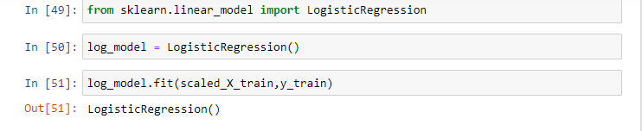

Figure 4.10: Model Training

Log_model.coef_ is an attribute of the "log_model" object, which is an instance of the Logistic Regression class from scikit-learn.

The "coef_" attribute stores the coefficients (also known as weights) of the features in the logistic regression model. In a logistic regression model, each feature has a corresponding weight that represents its importance in predicting the target variable. The "coef_" attribute stores these weights as a NumPy array, where each weight corresponds to a specific feature in the input data.

The coefficients can be used to understand the relationship between the features and the target variable. For example, a positive coefficient for a feature indicates that an increase in the feature value is associated with an increase in the predicted probability of the positive class, while a negative coefficient indicates that an increase in the feature value is associated with a decrease in the predicted probability of the positive class.

Note that the "coef_" attribute is only available after the "log_model" has been trained on the data using the "fit" methodFigure 4.12: Error rate of the optimal values of k

Positive values indicate that an increase in the feature value is associated with an increase in the predicted probability of the positive class, while negative values indicate that an increase in the feature value is associated with a decrease in the predicted probability of the positive class. The magnitude of the values indicates the strength of the association between the feature and the target variable.

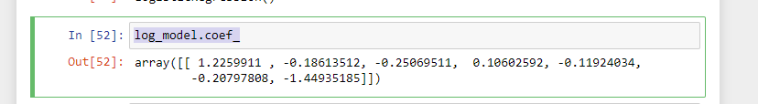

Figure 4.11: LRC Classifier

After training the LR classifier with the training dataset **Using Cross-Validation to find a well-performing C value for the hyper-parameter search** the testing dataset was used to evaluate the performance of the LR classifier, as shown in Figure 4.12. Figure 4.13 and Figure 4.14 shows the confusion matrix and the ROC-AUC curve of the LR classifier respectively.

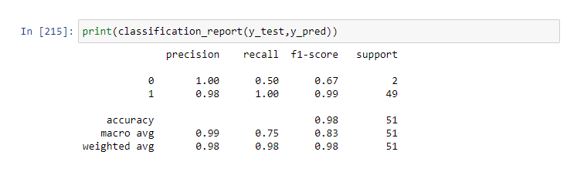

R2_score = 0.47959183673469385

accuracy_score(y_test,y_pred) = 0.9803921568627451

confusion_matrix(y_test,y_pred) = array([[ 1, 1],

[ 0, 49]],)

F1 Score: 0.990

Figure 4.12: LRCV Classifier’s performance on the testing dataset

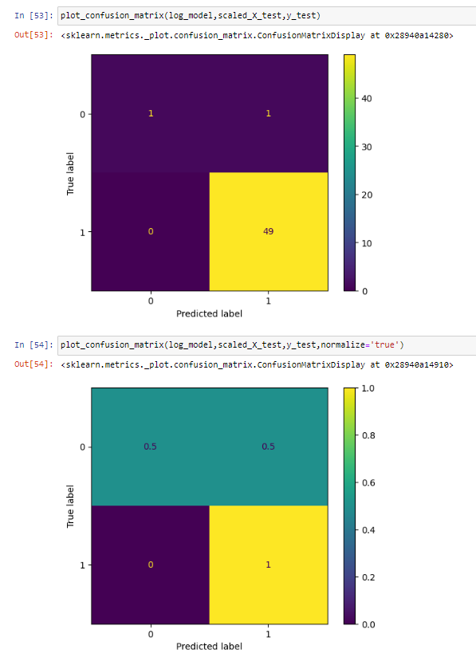

Figure 4.13: Confusion Matrix for the LRCV Classifier

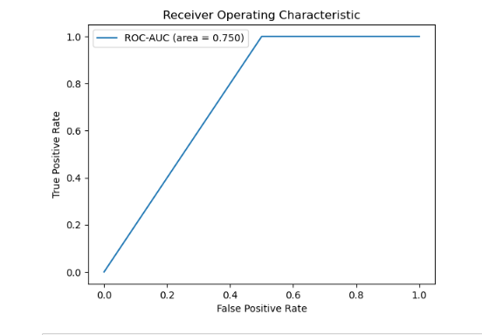

**Figure 4.14: ROC-AUC curve for the LRC Classifier**

## **DECISION TREE CLASSIFIER:**

In decision tree classifier the root node represents the entire dataset, and it's used to make the first test on a feature. Based on the outcome of the test, the data is split into subsets and passed down the branches of the tree. The process of making a test and splitting the data is repeated at each internal node, creating a new test and new branches. The process of splitting continues until a stopping criterion is met, such as a maximum tree depth is reached or a minimum number of samples per leaf is reached.

At the end of the tree, each final subset of data is represented by a leaf node. The predicted class label or real-valued prediction for a given observation is based on the majority class label or average value, respectively, of the data in the subset represented by the corresponding leaf node.

Figure 4.15: Predicting with the Decision Tree Classifier

The performance evaluation on a testing dataset for the Decision Tree Classifier is shown in Figure 4.16. Figure 4.17 and Figure 4.18 shows the confusion matrix and the ROC-AUC curve of the Decision Tree Classifier respectively.

**SCATTER PLOTS**

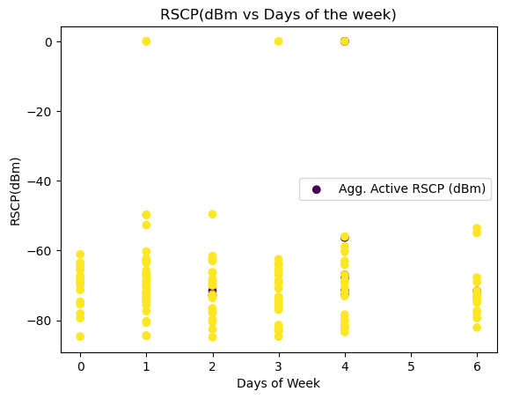

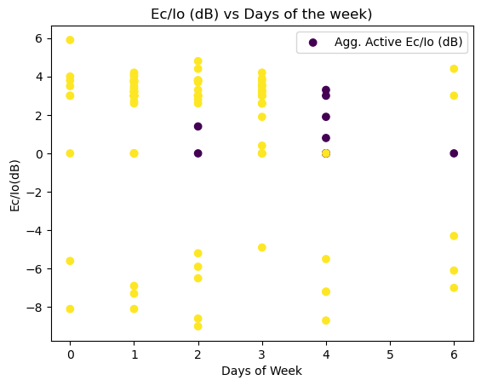

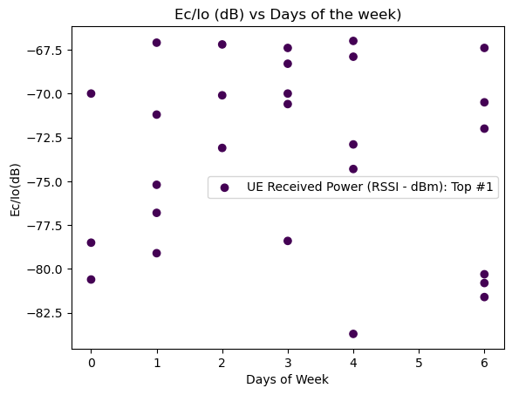

**3D scatterplot of Longitude, Latitude and Call Established**

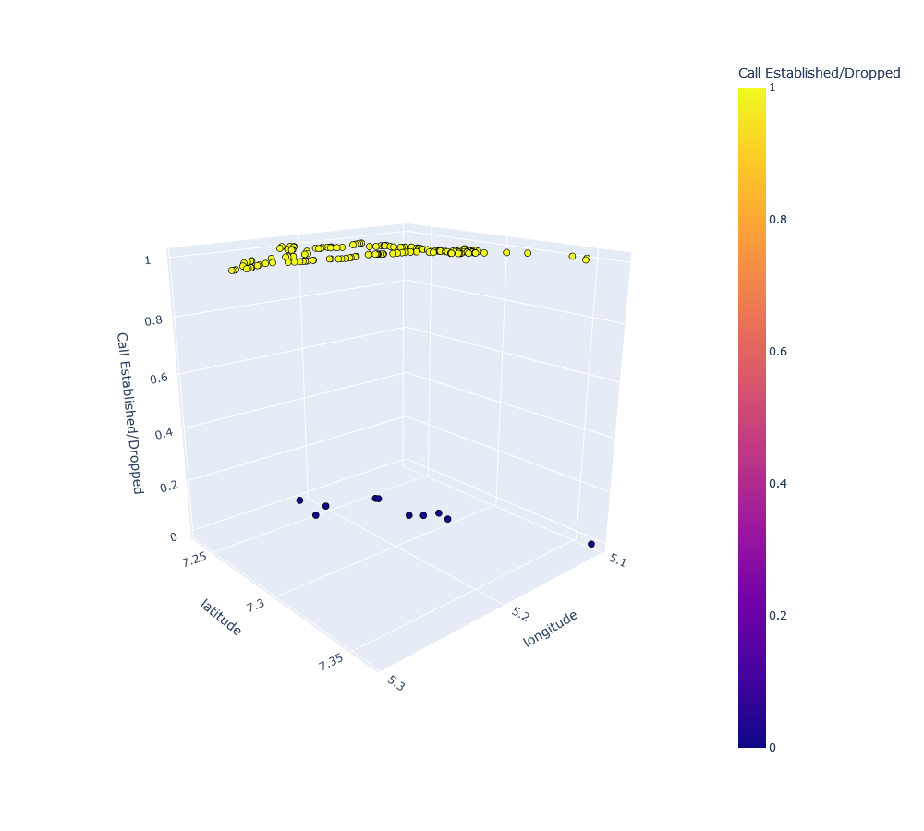

**Geographical Distribution**

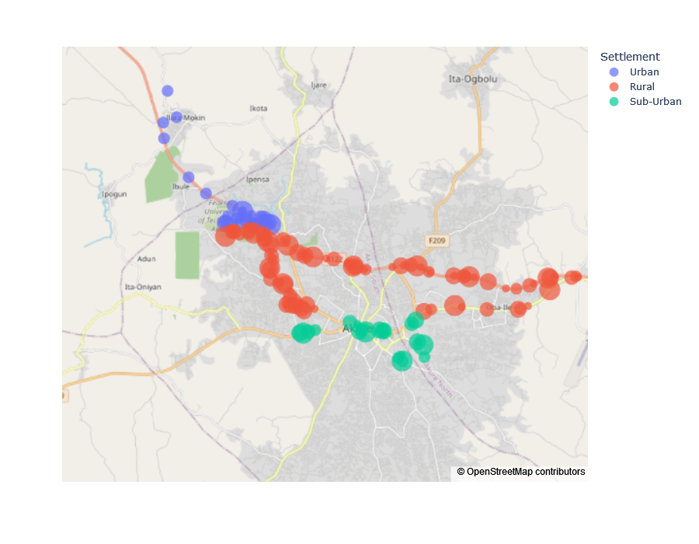

**Target Variable Distribution**

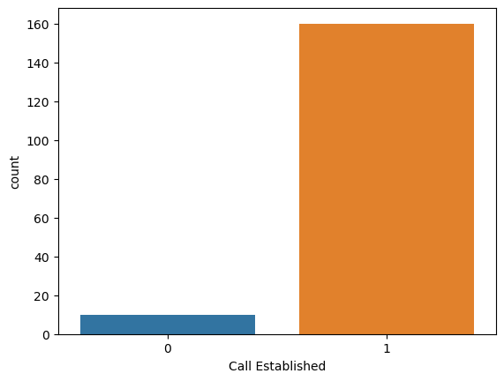

From the histogram, above it can be shown that the dataset has imbalance distribution of Call established and call dropped. The imbalance are taking care of by resampling the training set(that is, upsampling the calls dropped to match up with call established).

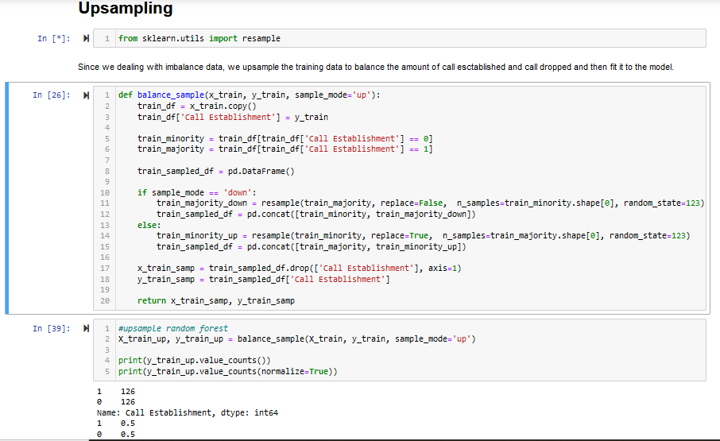

Make Prediction Function

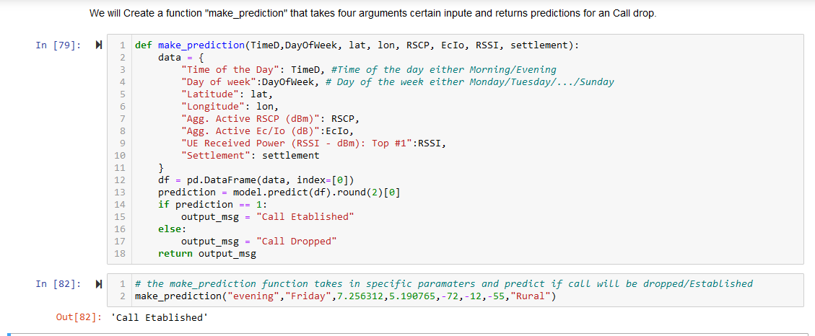

Odd Ration of First five Largest Coefficients

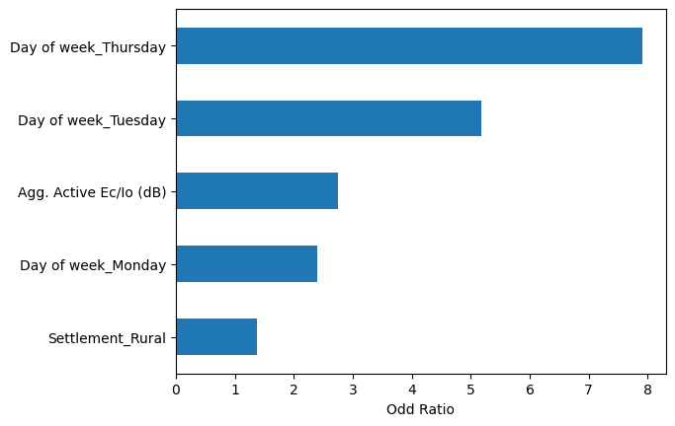

[1] B. Fatimah, “Comparative analysis of traffic congestion of mobile communication networks in Osogbo, Nigeria,” *JEMT*, vol. 6, pp. 25–32, 2018.

[2] J. Pisarov and G. Mester, “IPSI TAR July 2020 - The Impact of 5G Technology on Life in the 21st Century,” vol. 16, pp. 11–14, Jul. 2020.

[3] S. Naseer *et al.*, “Enhanced Network Anomaly Detection Based on Deep Neural Networks,” *IEEE Access*, vol. 6, pp. 48231–48246, 2018, doi: 10.1109/ACCESS.2018.2863036.

[4] O. F. Oseni, S. I. Popoola, H. Enumah, and A. Gordian, “RADIO FREQUENCY OPTIMIZATION OF MOBILE NETWORKS IN ABEOKUTA , NIGERIA FOR IMPROVED QUALITY OF SERVICE,” pp. 174–180, 2014.

[5] Infovista, “TEMS Investigation – Mobile Network Drive Testing | Infovista,” 2021.

[6] ASCOM, “TEMS.Investigation: TEMS Investigation is a complete, cost-effective and conveniently compact solution for the active field engineer.,” 2014.

[7] G. Sati and S. Singh, “A Review On Outdoor Propagation Models in Radio Communciation,” *International Journal of Computer Engineering & Science*, vol. 4, no. 2, 2014.

[8] O. T. Ajayi, S. O. Onidare, A. A. Ayeni, Q. R. Adebowale, S. O. Yusuf, and A. Ogundele, “Performance Evaluation of GSM and WCDMA Networks: A Case Study of the University of Ilorin,” *International Journal on Electrical Engineering and Informatics*, vol. 13, no. 1, pp. 87–106, Mar. 2021, doi: 10.15676/ijeei.2021.13.1.5.

[9] S. O, S. N. O, O. A. O, and O. L. I, “Path Loss Measurement and Modeling for Lagos State G.S.M Environments,” *Review of Computer Engineering Research*, vol. 3, no. 4, pp. 69–81, 2016, doi: 10.18488/journal.76/2016.3.4/76.4.69.81.

[10] A. A. , and T. O. B. Ponnle, “Assessment of Interdependence of Key Performance Indicators in Voice Traffic of Glomobile Network in Akure, Nigeria,” *AJER American journal of Engineering Research*, Feb. 2019.

[11] H. Lasisi and B. F. Aderinkola, “Comparative analysis of traffic congestion of mobile communication networks in Osogbo , Nigeria,” *Journal of Engineering and Manufacturing Technology*, vol. 6, 2018.

[12] A. Aburas and K. A. Al-Mashouq, “Call Quality Measurement and Application in Telecommunication Network,” 2011.

[13] F. Ndidi Ugwoke, K. Chinedu Okafor, I. Madonna Onwusuru, U. Chidiebele, K. Okafor, and I. Onwusuru, “Information Systems,” 2014. [Online]. Available: www.iiste.orgwww.cisdijournal.net

[14] A. Aburas and P. K. Al-mashouq, “Call Quality Measurement and Application in Telecommunication Network,” pp. 1–6, 2011.

[15] K. C. Okafor, I. M. Onwusuru, U. C.C, and U. F.N, “Using Software Engineering Approach in Mitigating QoS Challenges in Mobile Communication Networks in Nigeria,” vol. 5, no. 1, pp. 131–148, 2014.

[16] B. Fatimah and Lasisi Hammed, “Comparative analysis of traffic congestion of mobile communication networks in Osogbo , Nigeria,” vol. 6, pp. 25–32, 2018.

[17] S. Oloruntoba Oyeyele *et al.*, “Assessment of Quality of Service of G.S.M. Networks in Ilorin Metropolis, Nigeria,” 2020, [Online]. Available: https://www.researchgate.net/publication/350827109

[18] C. Mbachu and R. Usiade, “CONGESTION CONTROL IN GLOBAL SYSTEM FOR MOBILE COMMUNICATION (GSM) NETWORK USING HYBRID MODEL ALGORITHM,” vol. 1, pp. 1–9, Mar. 2016.

[19] F. M. Dahunsi and A. A. Akinlabi, “Measuring mobile broadband performance in Nigeria: 2G and 3G,” *Nigerian Journal of Technology*, vol. 38, no. 2, p. 422, Apr. 2019, doi: 10.4314/njt.v38i2.19.

[20] J. O. Mebawondu, “Comparative Analyses of Machine Learning Paradigms for Operators’ Voice Call Quality of Service,” 2021, pp. 66–79. doi: 10.1007/978-3-030-69143-1_6.

[21] P. Uthansakul, P. Anchuen, M. Uthansakul, and A. A. Khan, “QoE-Aware Self-Tuning of Service Priority Factor for Resource Allocation Optimization in LTE Networks,” *IEEE Trans Veh Technol*, vol. 69, no. 1, pp. 887–900, Jan. 2020, doi: 10.1109/TVT.2019.2952568.

[22] X. Zheng, W. Lai, H. Chen, and S. Fang, “Data Prediction of Mobile Network Traffic in Public Scenes by SOS-vSVR Method,” *Sensors*, vol. 20, no. 3, p. 603, Jan. 2020, doi: 10.3390/s20030603.

[23] M. Li, H. Xu, Z. Tu, T. Su, X. Xu, and Z. Wang, “A Deep Learning based Personalized QoE/QoS Correlation Model for Composite Services,” in *2022 IEEE International Conference on Web Services (ICWS)*, IEEE, Jul. 2015, pp. 312–321. doi: 10.1109/ICWS55610.2022.00053.

[24] B. M. Kuboye, “Evaluation of Broadband Network Performance in Nigeria,” *International Journal of Communications, Network and System Sciences*, vol. 10, no. 09, pp. 199–207, 2017, doi: 10.4236/ijcns.2017.109011.

[25] V. B. Umoh, U. S. Ukommi, and U. M. Ekpe, “A comparative study of user experienced mobile broadband performance,” *Nigerian Journal of Technology*, vol. 41, no. 3, pp. 560–568, Nov. 2022, doi: 10.4314/njt.v41i3.16.

[26] A. M. Miyim and A. Wakili, “Performance Evaluation of LTE Networks,” in *2019 15th International Conference on Electronics, Computer and Computation (ICECCO)*, IEEE, Dec. 2019, pp. 1–6. doi: 10.1109/ICECCO48375.2019.9043271.

[27] O. O. Erunkulu, E. N. Onwuka, O. Ugweje, and L. A. Ajao, “Prediction of Call Drops in GSM Network using Artificial Neural Network,” *Jurnal Teknologi dan Sistem Komputer*, vol. 7, no. 1, pp. 38–46, Jan. 2019, doi: 10.14710/jtsiskom.7.1.2019.38-46.

[28] Signal Booster, “WHAT IS A CELL PHONE SIGNAL BOOSTER AND HOW DOES IT WORK?,” *Signal Booster.com*, 2020.

[29] T. Liu and A. E. Cerpa, “Data-driven link quality prediction using link features,” *ACM Trans Sens Netw*, vol. 10, no. 2, pp. 1–35, Jan. 2014, doi: 10.1145/2530535.

[30] Bhutani, *4G: LTE/LTE-Advanced for Mobile Broadband*. Elsevier, 2014. doi: 10.1016/C2013-0-06829-6.

[31] O. I. Oluwadare and O. Julius, “Regional analysis of locations of public educational facilities in Nigeria : The Akure region experience,” vol. 4, no. July 2011, pp. 428–442, 2015.

[32] M. Grandini, E. Bagli, and G. Visani, “Metrics for Multi-Class Classification: an Overview,” Aug. 2020.

[33] S. Marabad, “CREDIT CARD FRAUD DETECTION USING MACHINE LEARNING,” *ASIAN JOURNAL OF CONVERGENCE IN TECHNOLOGY*, vol. 7, no. 2, pp. 121–127, Aug. 2021, doi: 10.33130/AJCT.2021v07i02.023.

1.